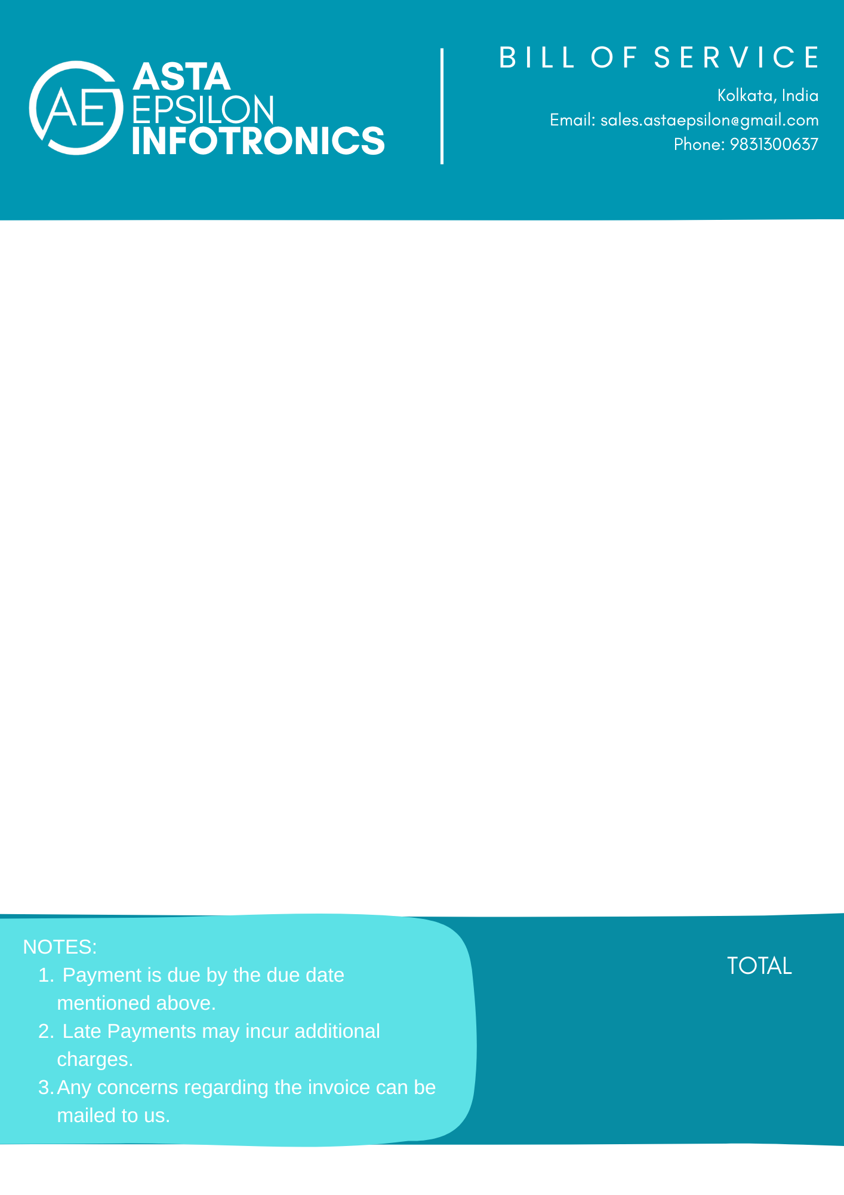
Client Details
Client Name: Red Soil Homestay
Client Address: Prantik, Birbhum
Billing Details
Bill Number: {{invoiceno}}
Billing Date: {{billdate}}
Due Date: {{duedate}}

Description of Service
Description | Quantity | Amount
Basic Portfolio Site | 1.0 | 7,999.00
Extra Media - Video Banner | 1.0 | 49.00
Influencer Connect - Surajit Saha Tier 1 | 1.0 | 9,999.00

18,047.00

